 |  |  |  | Hugo Wu
 |  |  |  | hugowu.weebly.com
 |  |  |  | (626)726.1249
 |  |  |  | hugowu.designer@gmail.com
OBJECTIVE
- Pursue a position of creative game developer in the gaming industry
SKILLS
Design | Engines |  | Programming |  |  | Software
- Event scripting  - Gameplay design  - Gameplay balance  - Cinematic storytelling | - Unreal Development Kit  - Unreal Tournament 3  - Source SDK  - G.E.C.K. |  | - C#  - Unreal Script  - Unreal Kismet  - Lua |  |  | - Visual Studio 2010  - Microsoft Office  - 3Ds MAX  - Photoshop CS5
PROFESSIONAL EXPERIENCE
International Games System, Arcade department  Taipei, Taiwn  Lead Game Designer |  |  |  | March 2006 ~ August 2010
- Managed a design team of 4 people and be responsible for assigning, scheduling and tracking tasks to game designers
- Wrote concept and design documents and worked closely with programmers, artists and sound developers to achieve project’s goals
- Collaborated with marketing team and made in-game promotion event to increase returning players in online music game, We Dancing Online Arcade
- Balanced overall difficulty and adjusted learning curve to successfully appeal casual players in shooting music game, Music GunGun!
- Planned and organized a tournament of GoGoBall, and received over 90% of positive feedback on survey at GTI Asia Taipei Expo, 2007
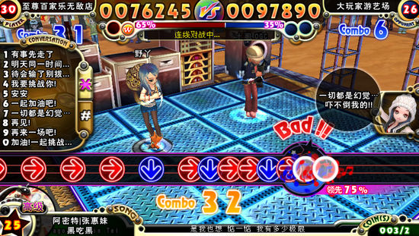  We Dancing Online Arcade |  | 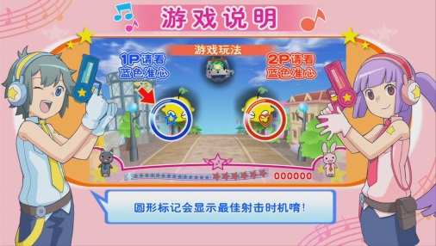  Music GunGun! |  |  | 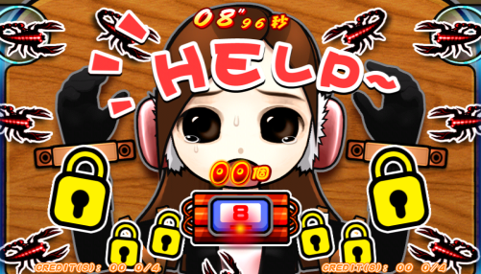  GoGoBall
International Games System, Arcade department  Taipei, Taiwn  Part-time QA Tester |  |  |  | November 2003 ~ June 2004  January 2000 ~ November 2002
- Provided feedback and solutions in multiple music games included Rock Fever, Rock Fever EX, Rock Fever 3, Rock Fever 4 and Percussion Master
- Improved quality of content and tuned properties in 2D fighting game, Martial Masters

 |  |  | Hugo Wu
 |  |  | hugowu.weebly.com
 |  |  | (626)726.1249
 |  |  | hugowu.designer@gmail.com
ACADEMIC PROJECTS
Voodudes  Level designer |  |  | August 2012 ~ December 2012
- A third-person single player action-adventure game built in Unreal Development Kit for PC
- Presented at Intel’s 2013 GDC booth
- Designed the layout and built game flow of Lafayette Cemetery level
- Scripted two multi-stage boss encounters in UnrelScript and Unreal Kismet
- Made 3 cut-scenes included 2 introductions of mini-boss and an opening of the final boss
Turret Laboratory  Individual project |  |  | September 2012 ~ October 2012
- Free-style Tower-Defense mod built in Half-Life 2: Episode 2
- Scripted three customized turrets and six waves of encounters in Hammer I/O
Misty Temple  Individual project |  |  | January 2012 ~ February 2012
- Fast-paced and high mobility multiplayer mod with a theme of leashed dragon in Unreal Tournament 3
- Best level design submission in the Guildhall’s Wall of Fame in Spring 2012
- Balanced multiplayer combat and adapted to board range of play styles
Rattack!  Team lead & level designer |  |  | October 2011 ~ December 2011
- Classic 2D side-scrolling platformer built in Torque X 2D for PC
- Voted into Guildhall’s Fall 2011 exhibition by the cohort
- Managed project and ran scrum through completed development cycle
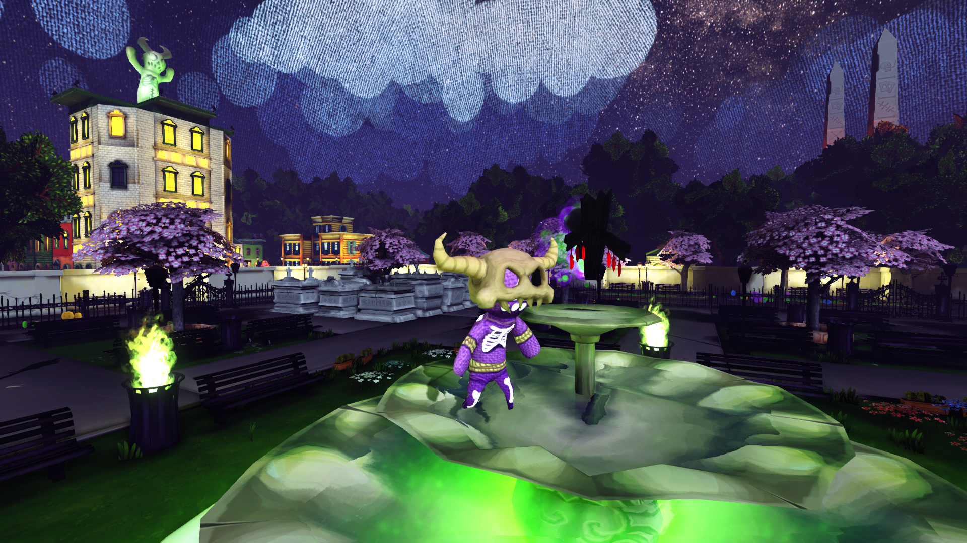  Voodudes | 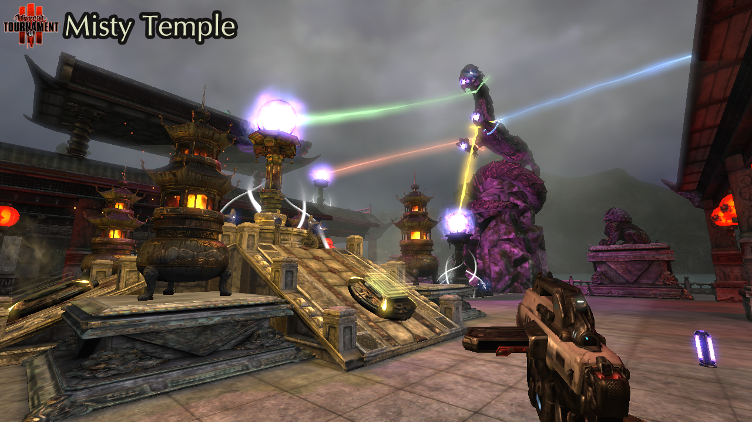  Misty Temple | 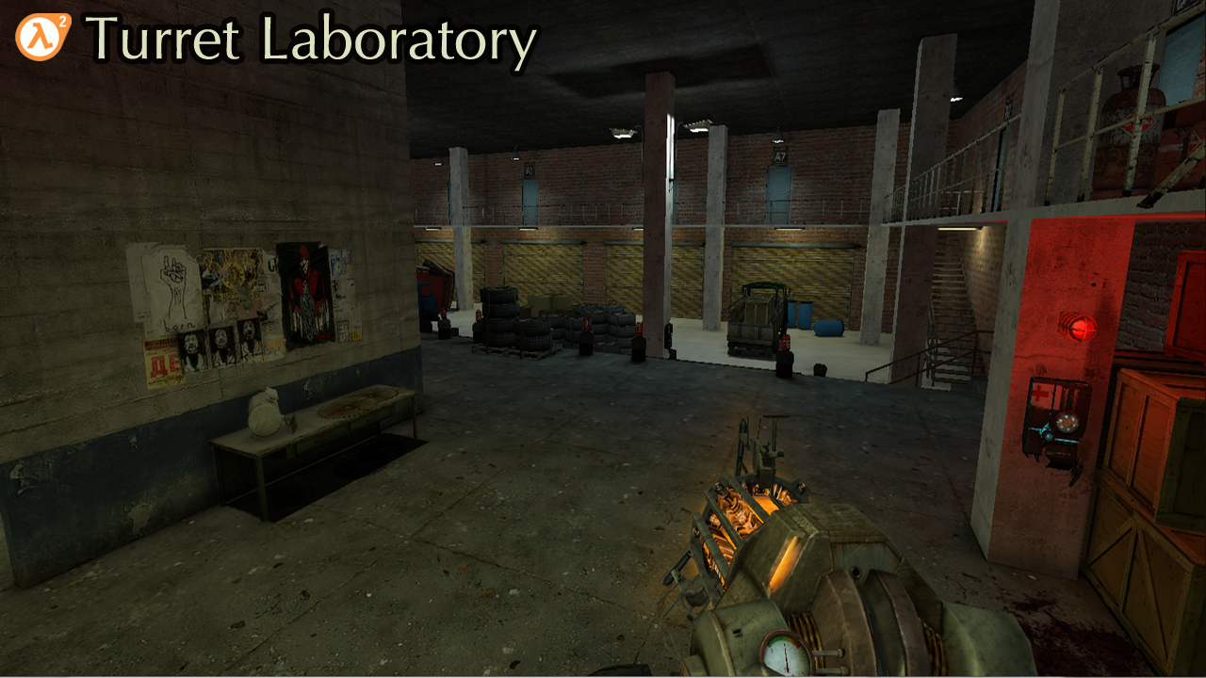  Turret Laboratory |  |  | 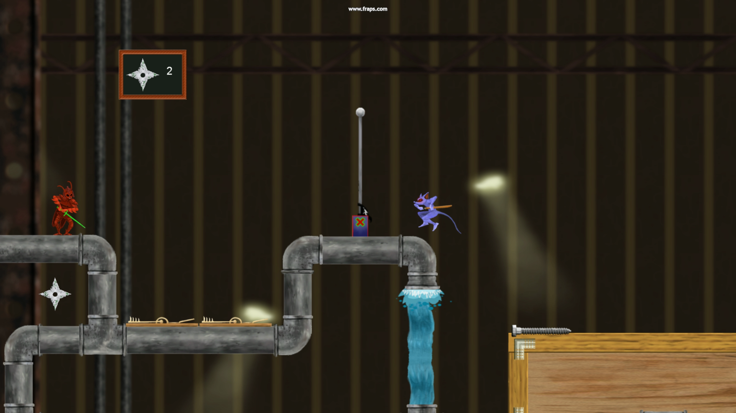  Rattack!
EDUCATION
The Guildhall at Southern Methodist University  Plano, Texas |  |  |  | August 2011 ~ May 2013
- The Master of Game and Interactive Media Design, Specialization in Level Design
- Thesis: Implement Dynamic Difficulty Adjustment in First Person Shooter Video Games
Fu Jen Catholic University  Taipei, Taiwan |  |  |  | September 1999 ~ June 2004
- Bachelor of Science in Computer Science and Information Engineering

